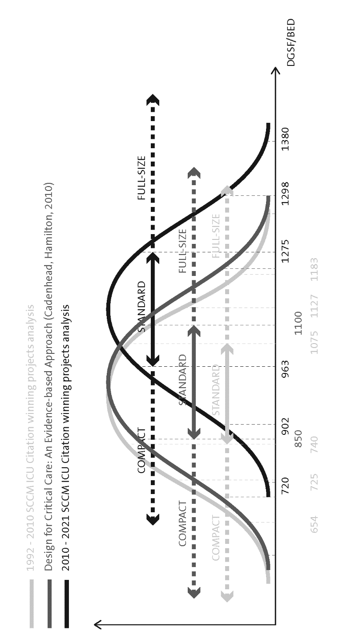

Liyang Zhang 2020-2021: ICU DESIGN BEST PRACTICES BASED ON SCCM ICU DESIGN CITATION PROJECTS (2010-2021)
- Create a comprehensive perspective of ICU background, functional relationship, circulation, and flow in a variety of scales of the ICU department.
- Analyze the best-practice SCCM ICU Design Citation projects (2010-2020).
- Improving a thorough check of key evidence-based design (EBD) considerations needed to facilitate and support design decision-making.
- Displaying the integrated design of a typical ICU department organized by 18 evidence-based design (EBD) goals in four categories, which are based on SCCM ICU Design Citation judging criteria.
- A detailed list of design features being provided as a checkpoint to measure the extent to which the design addresses key issues/considerations and achieves EBD goals.
- Develop a set of future design challenges that can be applicable for future design and innovation.

